类的CBO和DAC

|  |  |  |
| --- | --- | --- |
| 类名 | CBO | DAC |
| Log | 6 | 4 |
| 调用其他类5，  被其他类调用1 | LogVO,Operation  UserVO,LogList |
|
| Storage | 5 | 4 |
| 调用其他类4，  被其他类调用1 | DealVO,StorageVO  StorageList,State |
|
|  |  |  |
| 类名 | CBO | DAC |
| FinanceIncome | 8 | 3 |
| 调用其他类7，  被其他类调用1 | FIncomeVO, FIncomePO  FinanceBankAccount |
| FinanceExpense | 8 | 3 |
| 调用其他类7，  被其他类调用1 | FExpenseVO, FExpensePO,  FinanceBankAccount |
| FinanceStatistic | 5 | 4 |
| 调用其他类 4  被其他类调用 1 | FExpenseVO, FIncomeVO,  FinanceIncome, FinanceExpense |
| FinanceBankAccount | 5 | 2 |
| 调用其它类 4  被其他类调用 1 | BankAccountVO,BankAccountPO |
| FinanceInitAll | 6 | 4 |
| 调用其它类 5  被其他类调用 1 | BankAccountPO,CarPO,  StoragePO,MemberPO, |
| FinanceFreight | 7 | 2 |
| 调用其它类 5  被其他类调用 2 | FinanceStrategyVO,  FinanceStrategyPO |
| InitItem | 6 | 4 |
| 调用其它类 4  被其他类调用 2 | FinanceBankAccount,  Car,  Storage,  Member |

Storage_DomainObject 相关的NOC和DIT

|  |  |  |
| --- | --- | --- |
| 类名 | NOC | DIT |
| DomanObject | 2 | 0 |
| Storage | 0 | 1 |
| Deal | 0 | 1 |

Log_DomainObject 相关的NOC和DIT

|  |  |  |
| --- | --- | --- |
| 类名 | NOC | DIT |
| DomanObject | 2 | 0 |
| Log | 0 | 1 |
| User | 0 | 1 |

Finance_Domain相关的NOC和 DIT

|  |  |  |
| --- | --- | --- |
| 类名 | NOC | DIT |
| DomanObject | 6 | 0 |
| FinanceIncome | 0 | 1 |
| FinanceExpense | 0 | 1 |
| FinanceStatistic | 0 | 1 |
| FinanceBankAccount | 0 | 1 |
| FinanceFreight | 0 | 1 |
| FinanceInitAll | 0 | 1 |

Log的内聚

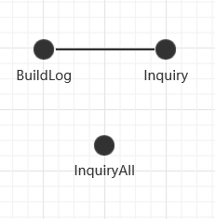 LCOM=0<1

Storage的内聚

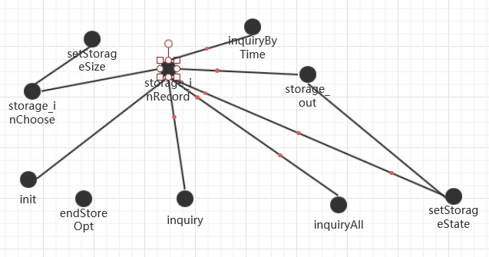LCOM=1

FinanceIncome的内聚度量

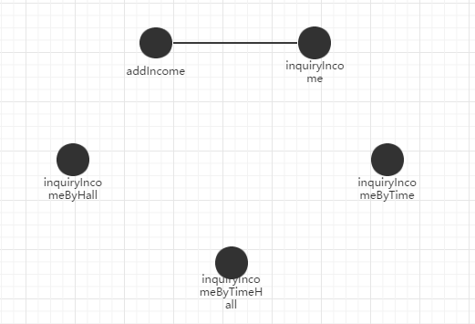LCOM=0<1

FinanceExpense的内聚度量

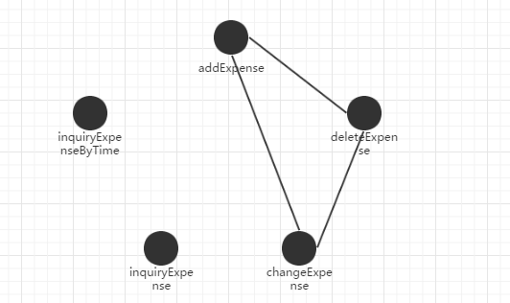

LCOM = 1<=1

FinanceStatistic的内聚度量

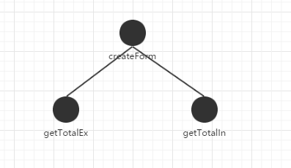

LCOM = 0 <1

FinanceBankAccount的内聚度量

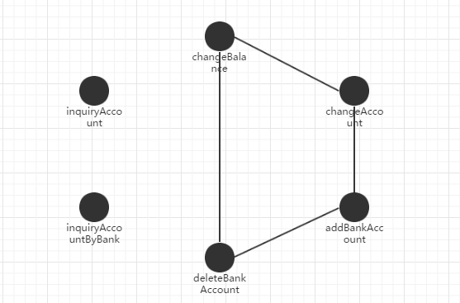

LCOM=1<=1

FinanceInitAll的内聚度量

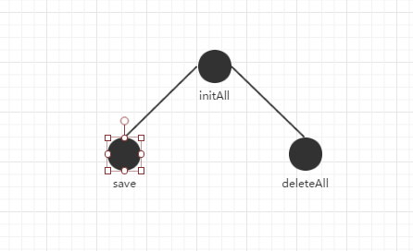

LOCM = 0 < 1